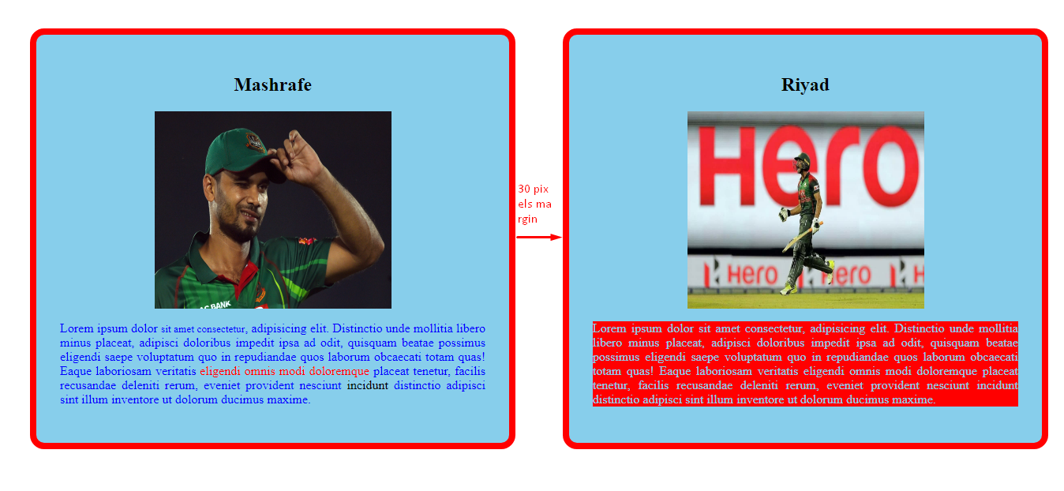

Create this webpage with the following conditions,

* Just pick your colors, you don’t need to follow any of these colors
* In stead of Mashrafe & Riyad, put images of **Sakib** & **Mushfiq**
* 30 pixels of gap between the divs of Sakib & Mushfiq (mentioned in the screenshot)
* The **body** should have 50 pixels of margin in every side
* I had solved the problem of setting the images & the names of the players in such a manner which was not discussed in the class & commented the code. You may just uncomment the code & solve it. BUT you will get a **bonus mark** if you solve in such a manner which was discussed in the class. In this way, you may face an obstacle but you can find a way if you read the **NOTE**

**NOTE**

margin won't work for inline elements, but you may override an inline element to block by writing the following line in CSS

**display: block**